create database Class;

use Class;

create table student(enrollmentno integer primary key,stuname varchar(20),section varchar(5),subjectid integer, marks integer);

insert into student values

(1,'Tim','A',1,70),(2,'Jim','A',2,75),

(3,'Kim','B',3,65),(4,'Tom','B',4,77),

(5,'John','C',5,60),(6,'Joe','C',1,82),

(7,'James','B',2,76),(8,'Henry','C',3,68),

(9,'Matt','B',4,71),(10,'Paul','A',5,79);

select \* from student;

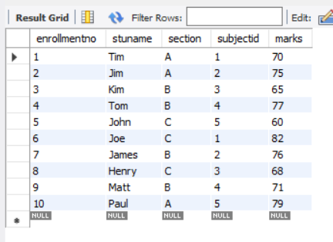

/\*section-wise Number of candidates \*/

select section,count(\*) from student group by section;

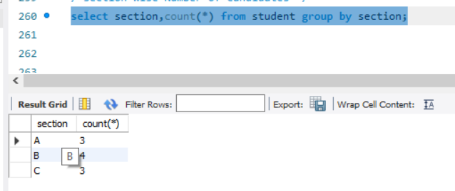

/\*section-wise Number of candidates who have secured more than or equal to 75 marks \*/

select section,count(\*) from student where marks>=75 group by section;

